The 3rd International Conference Challenges to Nacional Defence in Contemporary Geopolitical Situation (CNDCGS'2024), 11 – 13 September 2024, Brno, Czech Republic
Practical Evaluation of New Insensitive Munition for Military Demands
Svajone Bekesiene
General Jonas Žemaitis Miltitary Academy of Lithuania, Silo g. 5A, LT-10322 Vilnius
Introduction. The basic requirements for explosives are high energy storage stability of chemical compounds (chemical stability) and maximum safety at work, when can be reached low sensitivity to impact and thermal effects and low toxicity. The high explosives currently used in the civilian and military sectors do not adequately meet modern safety requirements and are one of the reasons for the search for new high energy compounds.
Scientific research carried out during 2014-2016 year was focused on N-(2,4,6-trinitrophenyl) -1H-1,2,4-triazol-3'-amine. These investigations aim was to create new high-energy potentially explosive materials. During the research, the modeling of new high-energy materials and their theoretical and experimental research were performed. As a result, N- (2,4,6-trinitrophenyl) -1H-1,2,4-triazol-3'-amine was synthesized. Based on the theoretical results of the investigation of this material, was determined that this material must be impact resistant and have better explosive properties than well-known TNT.
Experiments on impact resistance of this material have been performed. The get results let to confirm that the theoretical assumption that the new explosive material N- (2,4,6-trinitrophenyl) -1H-1,2,4-triazol-3'-amine is impact resistant as well as TNT. In this way the results of the theoretical studies were validated experimentally. In addition, the results of theoretical studies let to conclude that the number and position of the amine and nitro groups in the molecule influence the chemical and thermal stability and explosive properties of the new explosive. Moreover it has been found that the introduction of nitro groups improves the explosive properties of a new high-energy material, and the additional amine group in some cases improves the impact resistance of N- (2,4,6-trinitrophenyl) -1H-1,2,4-triazol-3'-amine.

Method of investigation. A synthesis of the materials needed for the experiments was performed. The melting point of the test substances was determined in open glass capillaries 1 mm in diameter using a MELT-TEMP instrument. All reagents used in this work were purchased from Sigma-Aldrich, Fluka and Merck and further used for work directly. The melting point of the synthesized materials was determined in 1 mm diameter open glass capillaries using a MELT-TEMP instrument. The progress of the reactions and the homogeneity of the resulting materials were controlled using thin layer chromatography (PSL) and silica gel 60 F254 on aluminum backing plates (Merck). IR spectra were recorded on KBr compressed tablets with a Perkin-Elmer spectrophotometer (FT-IR Spectrum BX II). LC-MS studies were performed on Agilent technologies 6246 and LCMS-2020, Shimadzu instruments.
The structure of the molecule and its fragments has been studied by the Becke’s three-parameter hybrid functional applying the non-local correlation provided by Lee, Yang, and Parr (B3LYP) [6], – a representative standard DFT method.

Investigation Results. The UV-Vis spectra of the materials under study were both measured and calculated, too. UV/Vis spectra measurements of N-(2,4,6-trinitrophenyl)-1H-1,2,4-triazol-3-amine were spectrophotometrically carried out applying Lambda 25 (Perkin Elmer, Waltham, MA, USA) UV-VIS spectrophotometer using 1.0 cm optical path cells and recording spectra with 0.4 nm accuracies in ethanol medium. IR spectra were recorded in KBr disc on a Perkin-Elmer spectrophotometer (FT-IR Spectrum BX II) at accuracies 1 cm⁻¹. The RAMAN spectra is presented in Fig. 1.

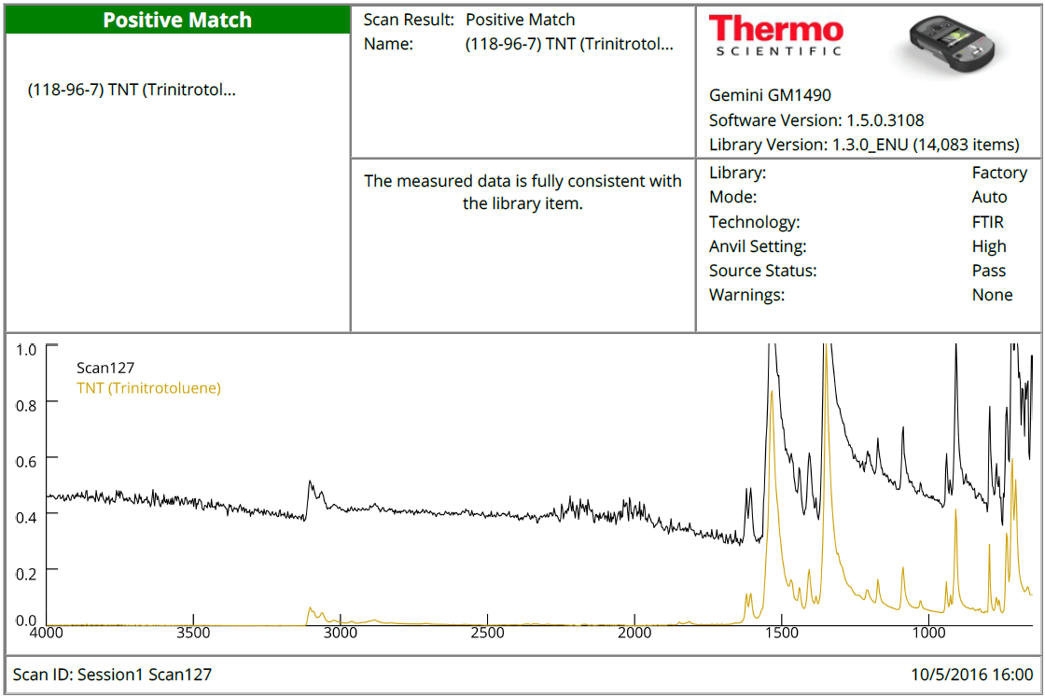

Fig. 1 The facsimile of the recorded RAMAN spectra issued by the device. The spectrum of synthesized TNT sample is shown in black line and yellow in the instrument database

Conclusions. The new high-energy (potentially explosive) materials have been created by rational molecular design. The principles of the latest quantum mechanics, organic chemistry and materials science methodologies were tested, practically applying their suitability to the development of such materials with desirable properties. Expected properties - impact resistance of new construction materials, high temperature, resistance to aging, etc. important parameters recently identified by NATO military specialists as basic in the "insensitive munition (IM)" category.
Theoretically (computer modeling) and experimental (spectroscopic, physico-chemical, mechanical, etc.) materials were further tested in preliminary but very important tests in practice, resistance to heating, hydrolysis, light exposure and contact with metals.
At the same time, a methodology for the identification of these new substances was developed, based on two basic principles: physical, - comparative spectroscopic analysis, and chemical, - new chemical analytical tests using color reactions. The key features for the identification of these new substances have been identified.

Limitations. However, further research is needed before this new material can be used in military applications as a new explosive. Such as:
• Synthesize materials for improved oxygen balance and explosive properties by transforming N- (2,4,6-trinitrophenyl) -1H-1,2,4-triazol-3'-amine and N- (3-amino-2,4,6- trinitrophenyl) -1H-1,2,4-triazol-3'-amine to their nitro derivatives, each having an additional nitro group in the triazole ring.
• Investigate N- (2,4,6-trinitrophenyl) -1H-1,2,4-triazol-3'-amino, N- (3-amino-2,4,6-trinitrophenyl) -1H-1,2 , Explosive properties of 4-triazol-3'-amino and N (3 ') - (2,4,6-trinitrophenyl) -1H-1,2,4-triazole-3', 5'-diamine and their improved nitro derivatives dependence on their degree of compression (density).
It is hoped that, as a result of the above-mentioned studies, the new explosives will be able to be used in military practice.

Acknowledgements. This work was conducted within the framework of the LMA scientific project "A theoretical and experimental investigations of new potentially explosive materials using quantum mechanical methods (NSPROG-I4)". The authors are thankful for the high-performance computing resources provided by the Information Technology Open Access Center of Vilnius University
Keywords: high energy materials; explosive detection; spectroscopy; UV spectra; IR spectra; calculations; B3LYP method.
References
[1] Senesac L, Thunda T G. Nanosensors for trace explosive detection. Materials Today 2008; 11: 28–36.
[2] Hwang J, Namhyun Choi N, Aaron Park A, Park J-Q, Chung J.H, Baek S, Cho S G, Baek S-J, Choo J. Fast and sensitive recognition of various explosive compounds using Raman spectroscopy and principal component analysis. Journal of Molecular Structure 2013;1039: 130–6.
[3] Moore D. Instrumentation for trace detection of high explosives. Rev. Sci. Instrum. 2004; 75: 2499–2512.
[4] Izake E L.Forensic and homeland security applications of modern portable Raman spectroscopy. Forensic Sci. Int. 2010; 202: 1–8.
[5] Tamuliene J, Sarlauskas J, Bekesiene S, Kleiza V. ITELMS’2014 : Proceedings of the 9th international conference, May 23-24, 2014, Panevėžys, Lithuania. Kaunas: Technologija, 2014.
[5] Steinfeld J I, Wormhoudt J, Explosives detection: A Challenge for Physical Chemistry. Annu. Rev. Phys. Chem. 1998; 49:203–32
[6] Becke A.D.Density-functional thermochemistry. iii. The role of exact exchange. J. Chem. Phys. 1993; 98:5648-52.
[7] Zhao Y, Pu J, Lynch B J, Truhlarand D G. Tests of Second-Generation and Third-Generation Density Functionals for Thermochemical Kinetics. Phys. Chem. Chem. Phys. 2004; 6:673–676.
[8] Kendall R A, Dunning Jr. T H, Harrison R J.Electron affinities of the first-row atoms revisited. Systematic basis sets and wave functions. J. Chem. Phys. 1992; 96:6796–6806.
[9] Scalmani G, Frisch M J, Mennucci B, Tomasi J, Cammi R, Barone V. Geometries and properties of excited states in the gas phase and in solution: Theory and application of a time-dependent density functional theory polarizable continuum model. J. Chem. Phys. 2006;124:094107: 1-15.

* Corresponding author. E-mail address: svajone.bekesiene@lka.lt

