(Single space 12pt)

Example of Scientific Manuscript Bold 16pt
(Single space 12pt)
Name SURNAME, Name SURNAME² (use style Author names), Bold 12pt
(Single space 12pt)
¹Department, Faculty, University, Address: street, postal code, city and country
²Department, Faculty, University, Address: street, postal code, city and country
(Single space 12pt)
E-mails: ¹email@email.com; ²email2@email.com (corresponding author)
(Single space 12pt)

Abstract 10pt
(Single space 10pt)
An abstract should be a brief summary of significant items of the main paper. An abstract should give concise information about the content of the core idea of the paper and clearly describe methods and the major findings reported in the manuscript. The structure of an abstract is the following: purpose, methodology, findings, research implications (if applicable), practical implications, the originality and value of the paper. The volume of an abstract should be no more than 600 symbols with spaces (approximately 100 words). Font Times New Roman 9 pt should be used for formatting an abstract. The customized styles or the key combinations of the template can be used for quick formatting of the whole manuscript (the full list is provided at the end of the template). 10pt
(Single space 10pt)
KEY WORDS: multidimensional database, professional counseling, SRLD architecture, Kendall W (some general terms, some subject-specific terms. There should be no more than 10 words. Keywords should be formatted in Times New Roman 10 pt; Font style – Italic)
(Single space 10pt)
- Introduction (Bold 10pt)
(Single space 10pt)
The program of the conference is intended to be published on Web page of LKA. The authors are requested to submit the manuscript (not exceeding ten pages), summary and the presentation title (in English, up to 1000 characters) before April 10, 2018 by E-mail as an attached file.
The article should be prepared using Microsoft Word XP for Windows. The font for English text should be Times New Roman. The text of manuscript must be printed on A4 format page using the following margins: top – 2,0 cm, bottom – 2,0 cm, left – 2,0 cm, right – 2,0 cm, paragraph indent 1,27 cm, a single line spacing.
(Single space 10pt)
Table 1.
Font style and size
Part of article | Font style | Size, pt
Title | Bold | 16
Authors | Bold | 12
Organization address | Italic | 10
E-mails: | Italic | 10
Abstract | Regular | 10
Key words | Italic | 10
Other text | Regular | 10
References | Regular | 10
Acknowledgements | Regular | 10
(Single space 10pt)
Care and attention must be given to below guidelines because importing graphics packages can often be problematic:
- All figures and tables must be placed and cited in the text in consecutive numerical order. In multi-part figures, each part should be labelled, e.g. Fig. 1(a), Fig. 1(b).

- The resolution of pictures should not be less than 300 dpi (dots per inch). If the size of the final file is too large (more than 10 MB), then the manuscript should contain the figures with minimised resolution, and the original figures must be provided in separate files.
- Figures in separate files should be saved in appropriate formats (see Table 2). The file name for the graphics
should include their short description (e.g. Fig. 1, Fig. 2a).
- Style and font size of all tables and figures should be the same in the whole manuscript. Do not use boldface for text within figures (diagrams, charts and schemes), for emphasis use Italic. All tables should be presented as a part of the text and should be editable (do not use any macros and screenshots for figures and tables).
- Title of the Figure. Obtain permission and include the acknowledgement required by the copyright holder if a figure is being reproduced from another source. For the title of the Figure use Times New Roman 10 pt.
- Conclusions or generalizations about your research should be presented using Times New Roman 10 pt.
- Please check if all names and surnames of the authors, also the details (title, year, volume, pages, etc.) in the list of references are correct. For more information and examples see section “References”.
(Single space 10pt)
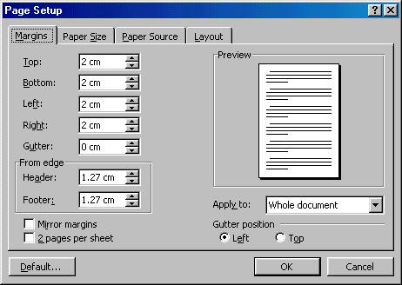 | 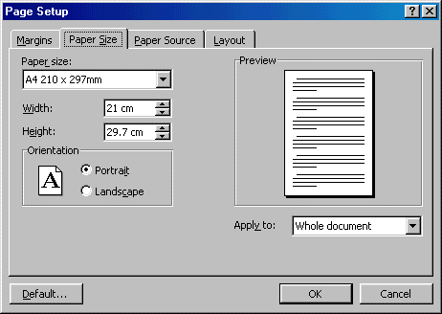
Fig.1. Page margins setup: top – 2,0 cm, bottom – 2,0 cm, left – 2,0 cm, right – 2,0 cm. | Fig. 2. Page size setup.
(Single space 10pt)
The main text should include previous research on the subject, methodology and/or theoretical framework, results of the research, and discussion with interpretation of results obtained. Use Italic (not boldface typing or capital letters) for emphasizing a word or a phrase. More requirements for a manuscript are provided in Table 1 (use style Paragraph body).
(Single space 10pt)
- The Mathematical Background (Bold 10pt)
(Single space 10pt)
Formulas, equations and their components presented in the text must be written in Equation Editor. The size of basic symbols in equations should correspond to the letter size of the main text –10 pt, indexes should be in 6 pt, sub-indexes – 5 pt.
All the numerals, including index numbers and Greek letters are presented in Regular type, variables in Italic. Matrices are written in square brackets [ ] and vectors in figurative brackets { }. Please do not use boldface for vectors and/or matrices. Equations should be formatted in Times New Roman 10 pt. Punctuate equations with commas or periods when they are a part of a sentence, as in
$a=\frac{b}{c}$ (use style Displayed equation, or Alt + Ctrl + E), (1)
where: a – explanation; b – explanation, etc. (all symbols must be explained).
Please confine equations to one column width 82 mm. If the equation is longer, it should be split at appropriate algebraic symbols. The parts of the longer equations must be horizontally left aligned in the equation editor. Equations are numbered by Arabic numerals in round brackets and aligned right. The punctuation and numbers of longer equations that occupy two or more lines, like (2), must be vertically centred with the last line of the equation.
(2)
Use an en-dash (–) rather than a hyphen (-) for a minus sign. Reformatting of running text, into which special characters such as Greek letters have been entered via the keyboard, can cause these characters to disappear. In order to avoid this problem, always insert special characters to your document from Insert → Symbol. In the Symbol dialog box select the required character and click Insert.
(Single space 10pt)
9 or 10 pt
Italic
5 or 6 pt
Fig. 3. The graphical interpretation of triggers results for suicidal behavior.
(Single space 10pt)
SPSS package allows us to verify the null hypothesis of equality of concordance coefficient to zero. Concordance statically significant if the p – value is less than the selected significance level α (it can be found in the column as “Asymp. Sig.”). By the way, k (n - 1) W is none other than Friedman $χ^{2}$statistic value (with asymptotic $χ^{2}$ distribution with n - 1 degrees of freedom), when calculated, or assess all candidates equally [1].
All mathematical operations were performed on collected data. The results are presented in the Table 4.
(Single space 10pt)

Conclusions (Bold 10pt)
(Single space 10pt)
Conclusions or generalizations about your research should be presented using Times New Roman 10 pt.
(Single space 10pt)

Acknowledgements (Bold 10pt)
(Single space 10pt)
People who contributed to the work should be listed in the acknowledgments, along with their contributions. You must ensure that anyone named in the acknowledgments agrees to being named. Please avoid identifying any of the authors prior to peer review! This paragraph should be in Times New Roman 10 pt.
(Single space 10pt)

References (Bold 10pt)
(Single space 10pt)
- Čekanavičius V., Murauskas G. Statistika ir jos taikymai. 2 d. 2004, Vilnius:TEV. -270 p.
- Ranerup A. Decision Support Systems for Public Policy Implementation: The Case of Pension Reform. Social Science Computer Review, 2008, 26 (4), p.428-445.
- Jakeman A.J., Letcher R.A. Integrated assessment and modelling: Features, principles and examples for catchment management, Environmental Modelling and Software, 2003,18, p.491-501.
- Cheney G., Zorn T.E., Planalp S., Lair D.J. 4 Meaningful Work and Personal/Social Well-Being/ in Communication Yearbook 32. Ed. Ch.S.Beck. Routledge. 2008. p. 137-186.
- Xiao L., Lewis P., Gibb A. Developing a security protocol for a distributed decision support system in a healthcare environment. ICSE’08. Proceedings of 30th International Conference on Software Engineering. Leipzig, 2008. p. 673-682.
Not less that 75% of the last page area should be filled.

¹ Corresponding author. E-mail address: svajone.bekesiene@lka.lt

